View documentation

written by Luke Mather

2019

# Introduction

This document is going to show screenshots of all of the views that have been created as well as explaining how they function and what they can be used for. Each view will have its own section, these sections will be the waiter/waitress view, kitchen view, admin view and counter view.

# Kitchen view

Below is a screenshot of the kitchen view in its initial state.

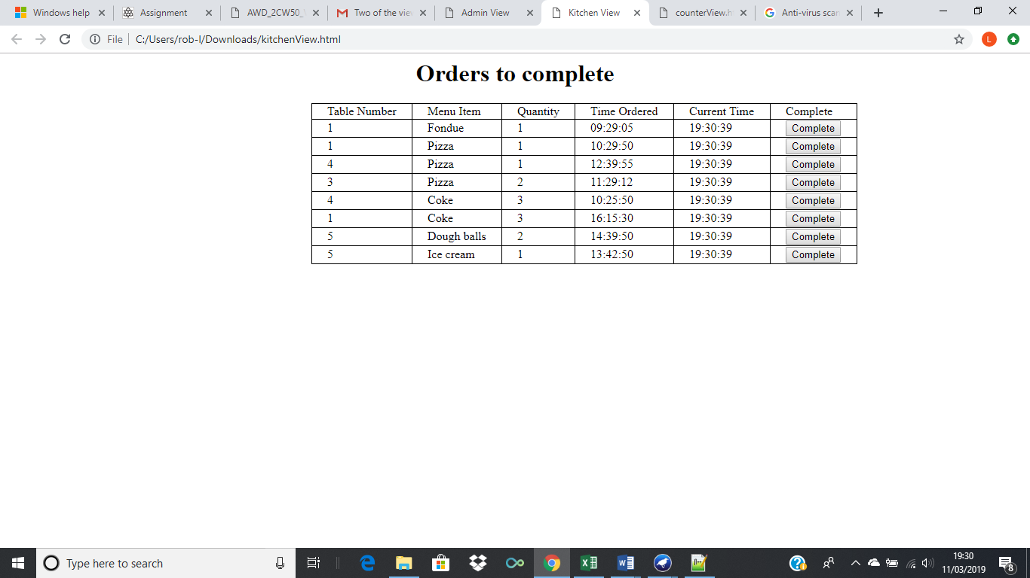

Figure 1 - Kitchen view

As shown in figure 1, the kitchen view shows the table number from which the order was received, the menu item that they ordered, how many of the item they ordered the item and the current time as well as a complete button. Each item comes as a separate order, so for example table one ordered fondue, pizza and coke, however they are listed as three separate orders with three separate complete buttons.

Once an order has been completed, a member of staff has to press the complete button on the row of the completed order, once they press the complete button, the relevant order will disappear, this is shown below via screenshot.

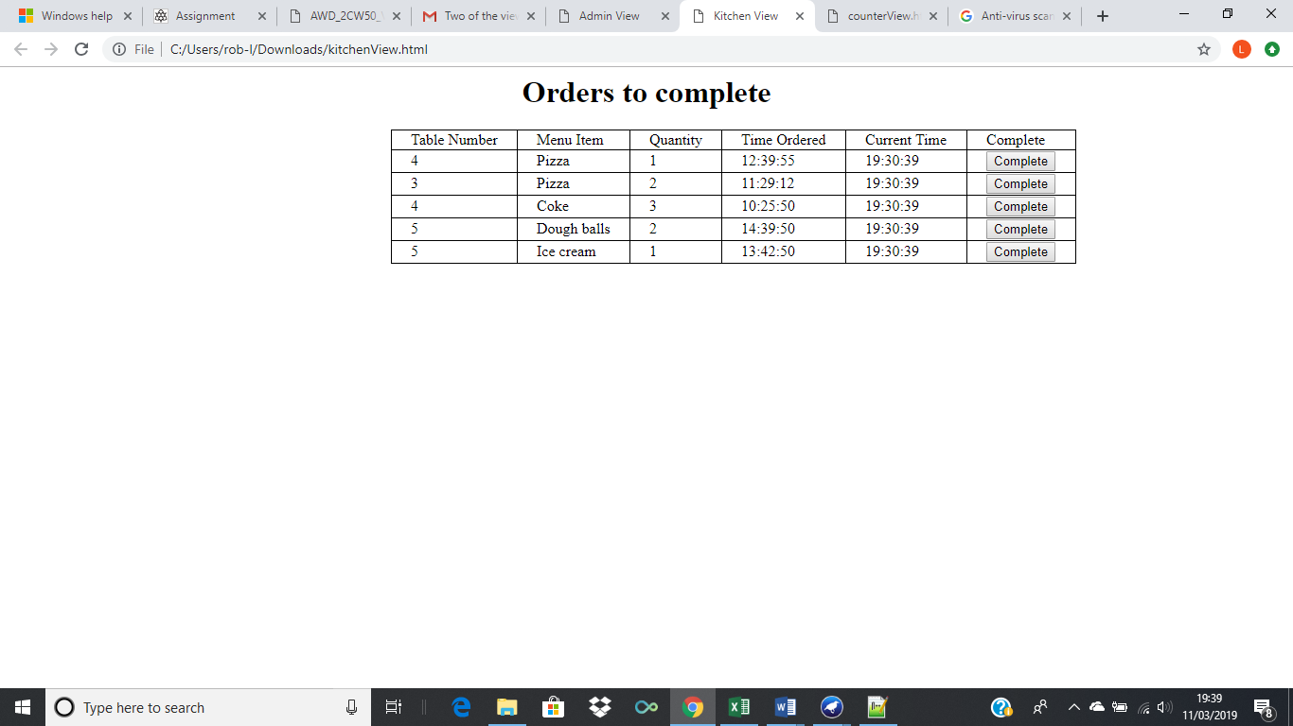

Figure 2 - Kitchen view with completed orders

Figure 2 shows the kitchen view when the fondue, pizza and coke orders from table one has been completed, as you can see once the complete button was pressed for those three orders, they were removed from the table and are no longer displayed for kitchen staff to see.

# Admin view

Below is a screenshot of the admin view in its initial state.

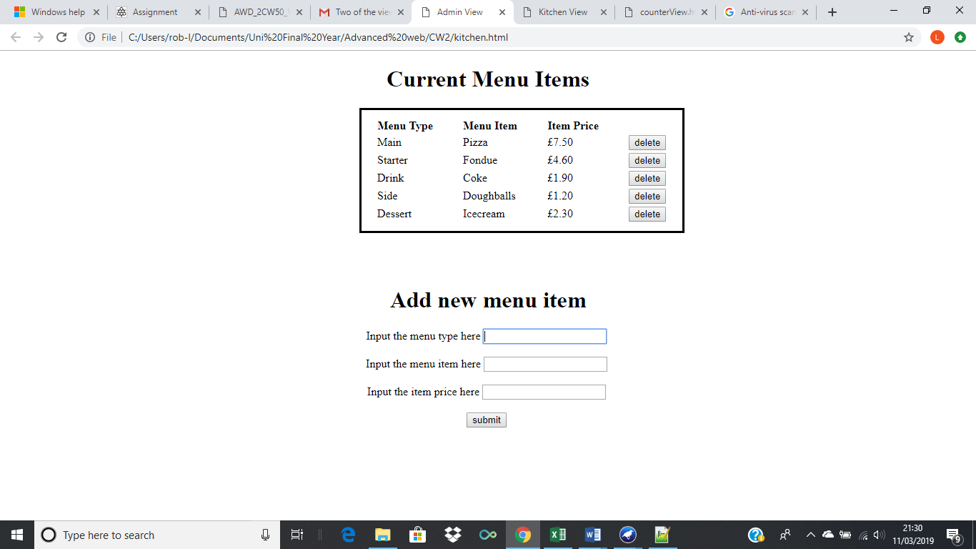

Figure 3 - Admin view

As shown in figure 3, the admin view shows current items on the menu, the table is split into the menu type, for example main or starter, the menu item and the items price as well as a delete button on the right. There are also three text boxes and a submit button at the bottom of the view which are to be used to add new items to the menu table above.

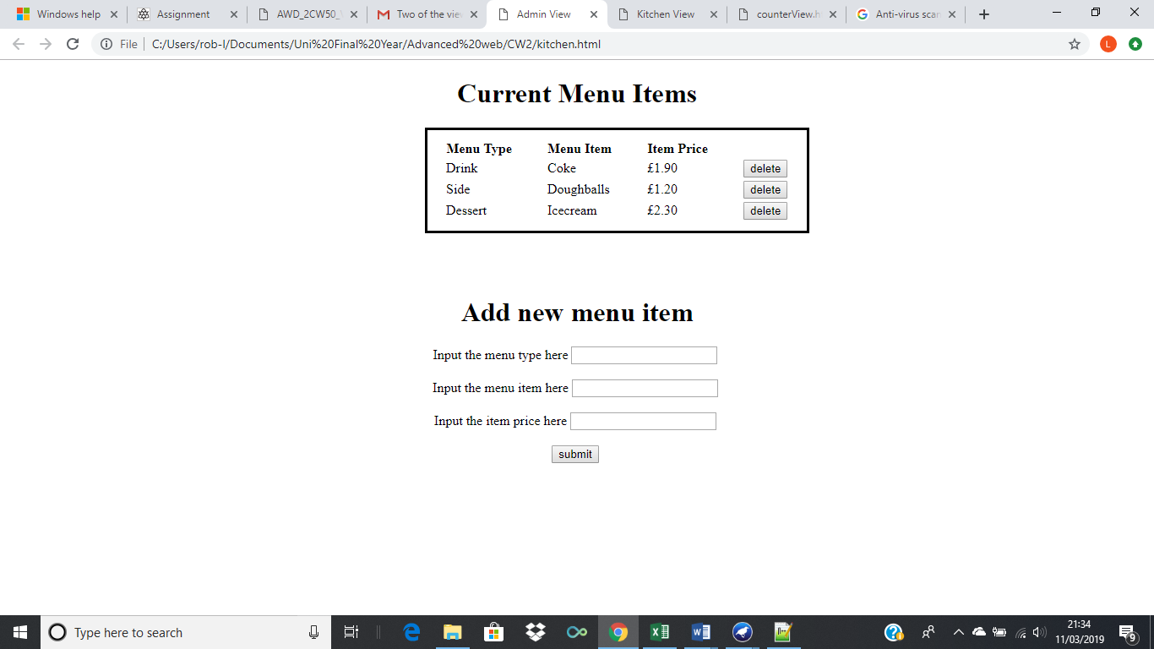

Figure 4 – Admin view with deleted menu items

Shown in figure 4, the menu items pizza and fondue have been deleted from the menu items table through their respective delete buttons, showing that when someone from admin presses the delete button for a menu item, it will be deleted instantly.

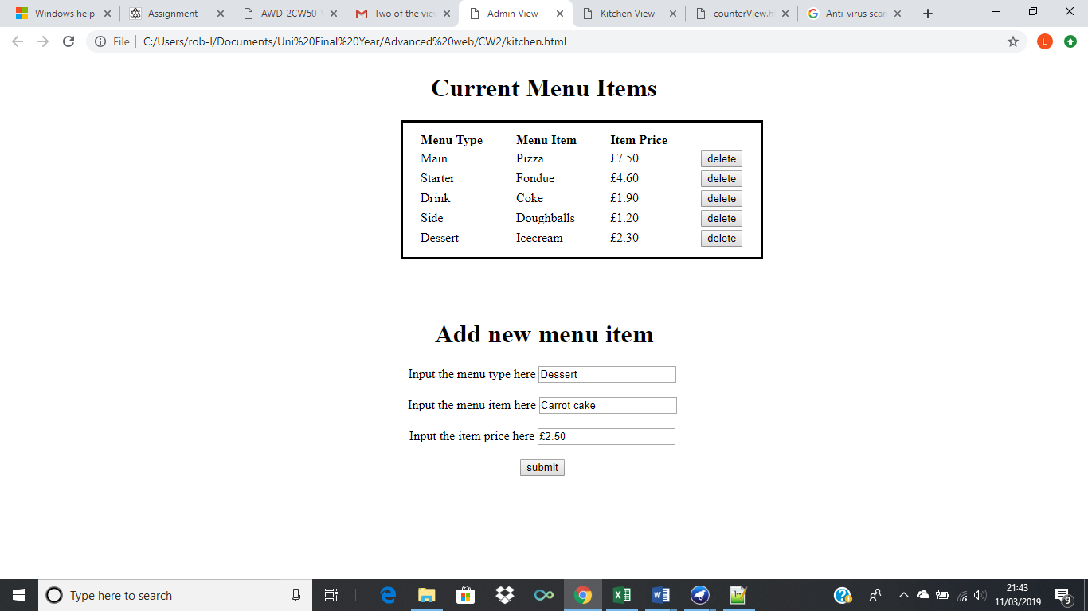

Figure 5 - Using add new item function in admin view

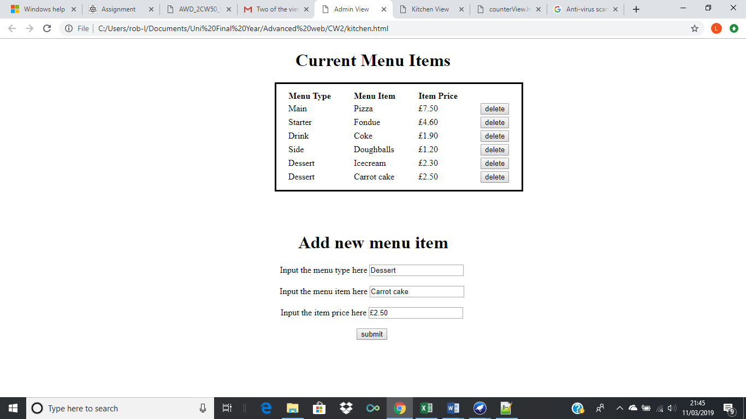

Figure 6 - New item added onto menu in admin view

As shown in figure 5, you type the menu type, menu item and item price into the relevant textboxes and then press the submit button, then the item, its type and its price will be added to the bottom of the menu items table along with a new delete button for that item, as shown in figure 6.

# Counter view

Below is a screenshot of the counter view in its initial state.

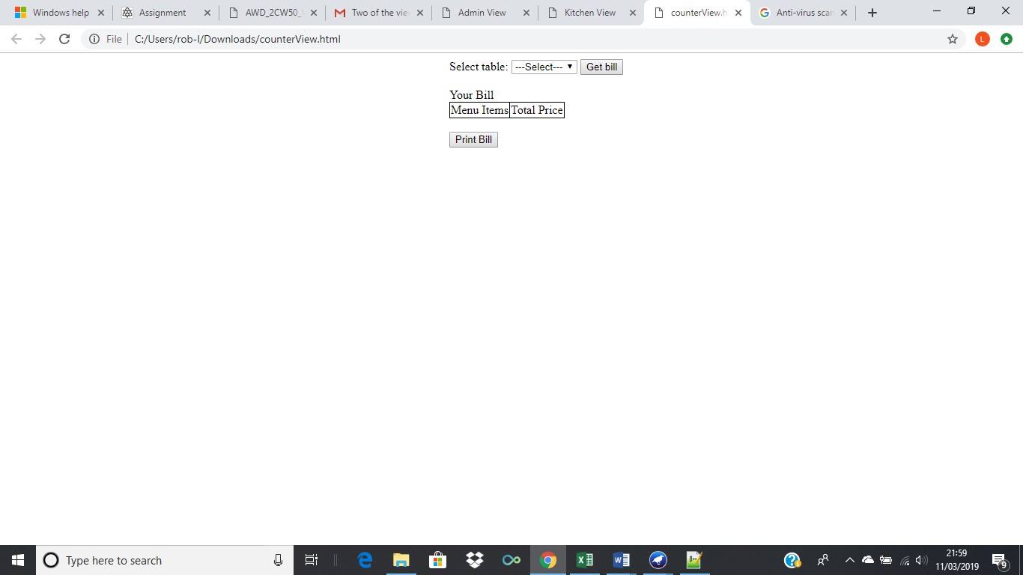

Figure 7 - Counter view

As shown in figure 7, the counter view has a drop-down box in which you can choose the table number of any table, there is also a “get bill” button, when you press this button you get the menu items and the total price of those items displayed in the “your bill” table. Finally, there is a “print bill” button which takes you to a print page in case a paper copy of the bill is required.

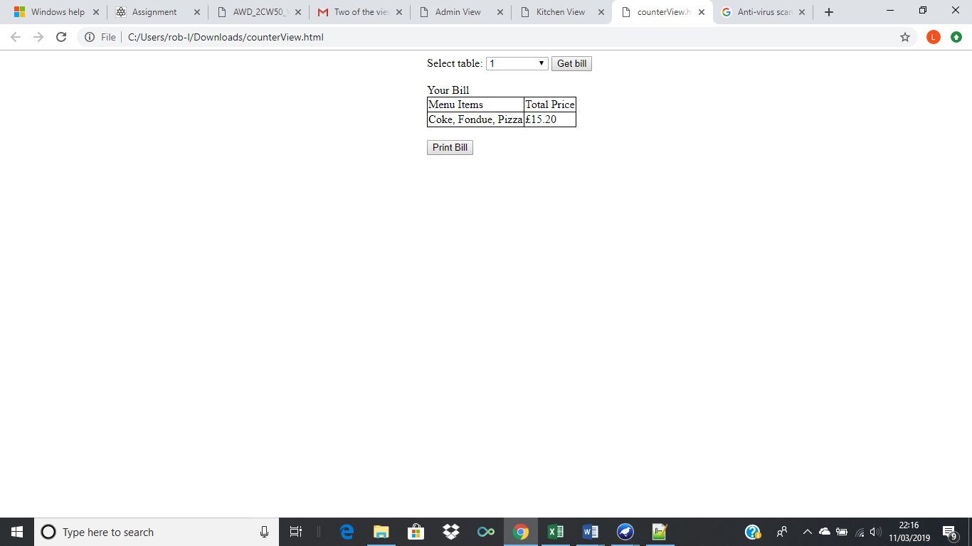

Figure 8 - select table and get bill functions used in counter view

Figure 8 shows that when you select a table from the drop-down box, for example table one and then press the “get bill” button, you will be shown all of the items ordered from that table as well as the total price of all these items combined.

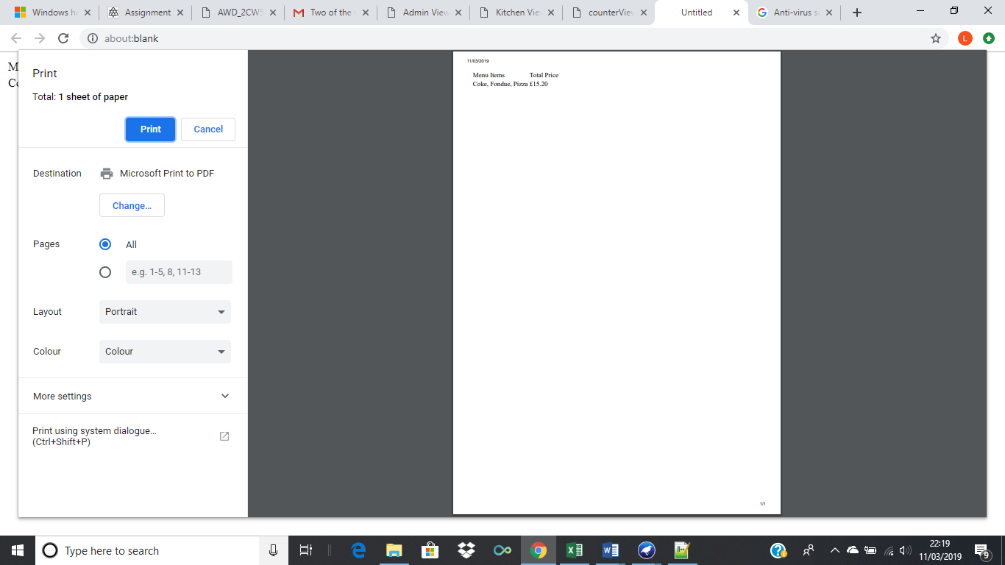

Figure 9 - print function in the counter view

Figure 9 shows what happens when you press the print button in the counter view, when you press the button you are taken to the page shown above that lets you print out the bill with ease.

# Waiter/Waitress view

Below is a screenshot of the waiter/waitress view in its initial state.

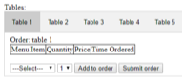

Figure

As shown in figure 10, the waiter/waitress view has buttons at the top of the page which are used to choose which table you wish to input an order for. There are also two drop down boxes which are used to choose an item to add to the order, and the quantity of the item being ordered. There is an “add to order” button which you press to add that item to the order and finally a “submit order” which is used to submit the order to the kitchen once it is completed. When adding an item from the menu to the order, as well as showing the item name and the quantity, the price of that item and the time the item was ordered is also shown in the order table.

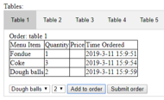

Figure

As shown in figure 11, the two dropdown boxes can be used to select a menu item and a quantity to add to the order, for example as shown in figure 11 one Fondue has been added. Once the menu item and quantity have been selected, the “add to order” button is to be pressed, when it is the selected item and quantity will be added to the bottom of the “order” table shown above.